Task 7: To create this.

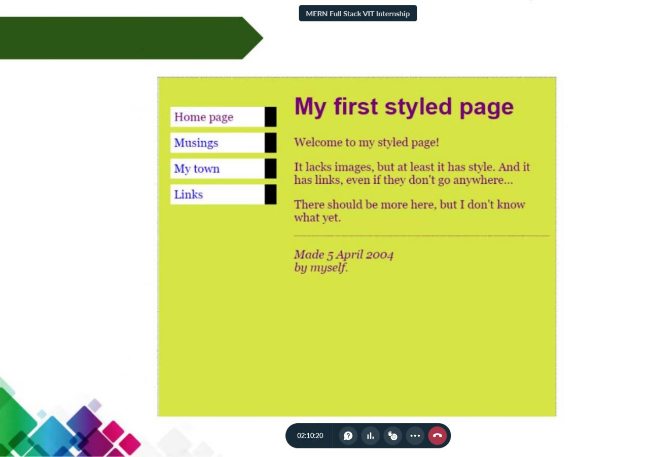

HTML code:

<html lang="en">

  <head>

    <link rel="stylesheet" href="styledPage.css" />

    <meta charset="UTF-8" />

    <meta http-equiv="X-UA-Compatible" content="IE=edge" />

    <meta name="viewport" content="width=device-width, initial-scale=1.0" />

    <title>Styled Page</title>

  </head>

  <body>

    <br />Styled Page - 20BCE2096 <br /><br />

    <div class="container">

      <div class="left">

        <div class="vnavbar">

          <ul>

            <li>

              <a href="#Home">Home Page</a>

              <div class="black"></div>

            </li>

            <li>

              <a href="#Musings">Musings</a>

              <div class="black"></div>

            </li>

            <li>

              <a href="#MyTown">My Town</a>

              <div class="black"></div>

            </li>

            <li>

              <a href="#Links">Links</a>

              <div class="black"></div>

            </li>

          </ul>

        </div>

      </div>

      <div class="right">

        <h1>My first styled page</h1>

        <p>

          Welcome to mu styled page! <br />

          It lacks images but at least it has style . And it has links even if

          they dont go anywhere... <br />

          There should be more here, but I dont know.

        </p>

        <hr style="color: red" />

        <p>

          Made May 20th 2023 <br />

          By myself

        </p>

      </div>

    </div>

  </body>

</html>

CSS code:

\* {

  box-sizing: border-box;

  margin: 10px;

}

.button {

  display: block;

  width: 100px;

  height: 50px;

  text-align: center;

  line-height: 50px;

  margin-bottom: 10px;

  color: #333333;

  cursor: pointer;

  transition:  width 0.3s, height 0.3s;

}

.button:hover {

  width: 150;

  height: 100px;

}

\* {

  box-sizing: border-box;

}

.container {

  display: flex;

  background-color: lightgreen;

  margin: 0px;

  height: 400px;

  justify-content: flex-start;

  align-items: flex-start;

}

.left {

  flex: 1;

  padding: 2rem;

  display: flex;

  flex-direction: column;

  justify-content: center;

  align-items: center;

}

.right {

  flex: 3;

  margin: 0.5rem 0rem;

}

.right h1 {

  color: purple;

}

.right p {

  color: red;

}

.vnavbar {

  list-style-type: none;

}

.vnavbar ul {

  list-style-type: none;

  padding: 0px;

  margin: 0px;

  display: flex;

  flex-direction: column;

}

.vnavbar li {

  margin: 0.2rem 0rem;

  display: flex;

  justify-content: space-between;

  text-align: center;

  padding: none;

  background-color: white;

}

.black {

  height: auto;

  width: 10px;

  margin-left: 5px;

  background-color: #333333;

}

.vnavbar a {

  display: block;

  text-decoration: none;

  color: #333333;

  padding: 5px;

  color: blue;

  transition: color 0.3s;

}

.vnavbar a:hover,

.vnavbar li:hover {

  color: white;

  background-color: orange;

}

Output:

